NMAP & WIRESHARK


Powerful Tools for Network Security and Analysis

part 1

Practice in LAB By: Nin Kanong
NMAP & WIRESHARK

Basic Nmap:
Nmap is a network mapper that has emerged as one of the most popular, free network discovery tools on the market. Nmap is now one of the core tools used by network administrators to map their networks. The program can be used to find live hosts on a network, perform port scanning, ping sweeps, OS detection, and version detection.
A number of recent cyberattacks have re-focused attention on the type of network auditing that Nmap provides. Analysts have pointed out that the recent Capital One hack, for instance, could have been detected sooner if system administrators had been monitoring connected devices. In this guide, we’ll look at what Nmap is, what it can do, and explain how to use the most common commands.
Kali> man nmap
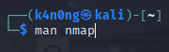

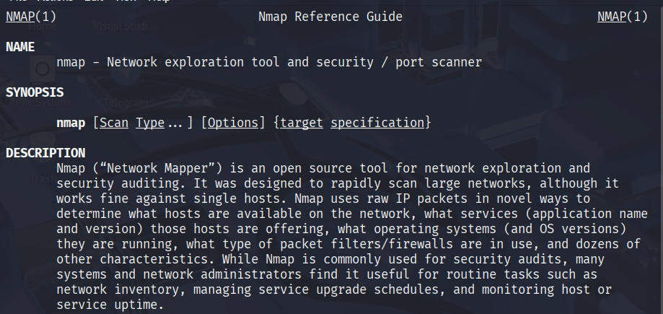

What is Nmap?
Nmap is Used to Scan:
- Enterprise-scale networks
- Small business networks
- Connected devices
- IoT devices and traffic
At its core, Nmap is a network scanning tool that uses IP packets to identify all the devices connected to a network and to provide information on the services and operating systems they are running.
The program is most commonly used via a command-line interface (though GUI front-ends are also available) and is available for many different operating systems such as Linux, FreeBSD, and Gentoo. Its popularity has also been bolstered by an active and enthusiastic user support community.
Nmap was developed for enterprise-scale networks and can scan through thousands of connected devices. However, in recent years Nmap is being increasingly used by smaller companies. The rise of the IoT, in particular, now means that the networks used by these companies have become more complex and therefore harder to secure.
This means that Nmap is now used in many website monitoring tools to audit the traffic between web servers and IoT devices. The recent emergence of IoT botnets, like Mirai, has also stimulated interest in Nmap, not least because of its ability to interrogate devices connected via the UPnP protocol and to highlight any devices that may be malicious.

Nmap provides information on:
- Every active IP so you can determine if an IP is being used by a legitimate service or an external attacker.
- Your network as a whole, including live hosts, open ports, and the OS of every connected device.
- Vulnerabilities — scan your own server to simulate the process that a hacker would use to attack your site.
- Basic scan:
kali> nmap google.com
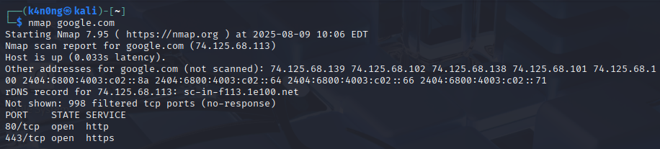

kali> nmap google.com facebook.com
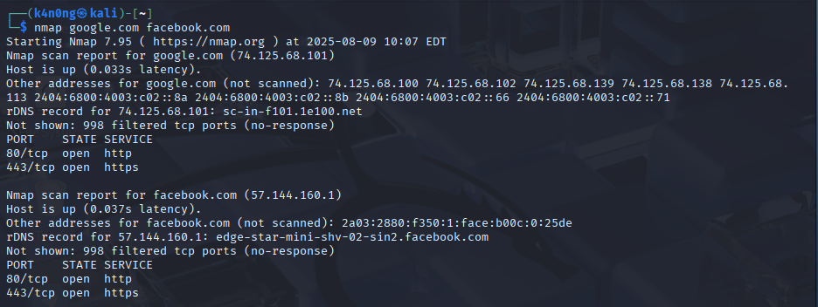
- Use metasploit for testing:
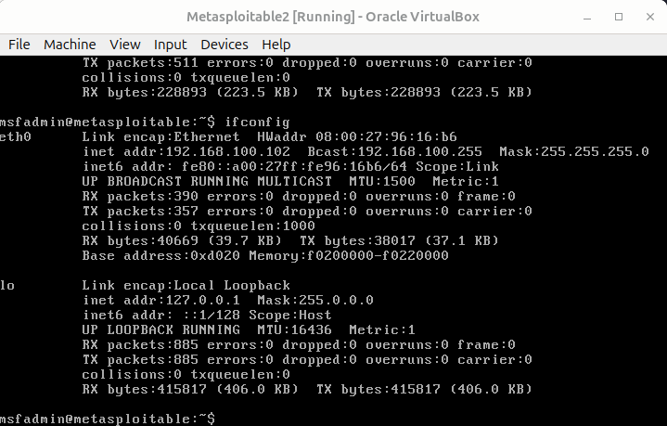
Because it has a lot of vulnerability and weakness.

kali> nmap 192.168.100.102
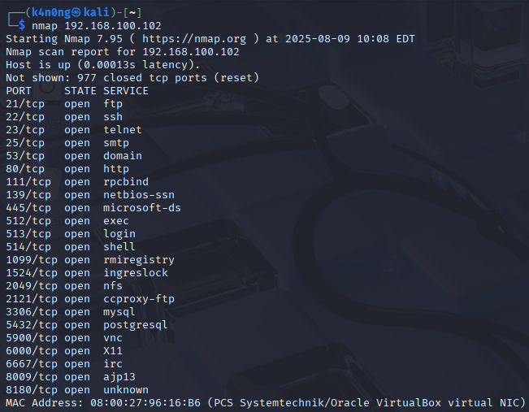

scan single target.

Kali> nmap 192.168.100.102 192.168.100.110 192.168.100.97
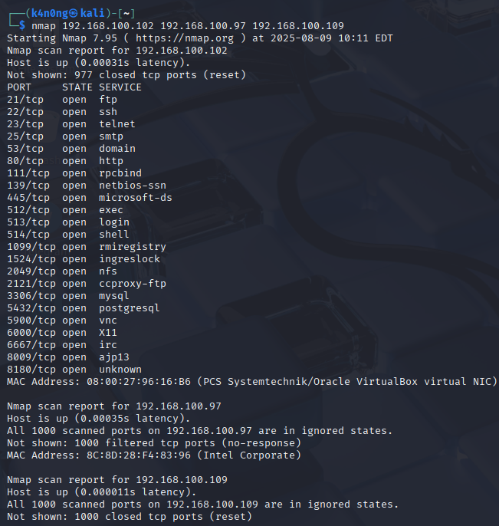

scan multiple hosts.
kali> nmap 192.168.100.1/24
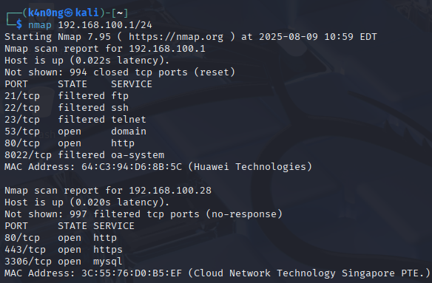
is used to scan a local network to discover which devices (IP addresses) are active and gather basic information about them. Scan an IP Range or subnet.

kali> nmap 192.168.100.1-200
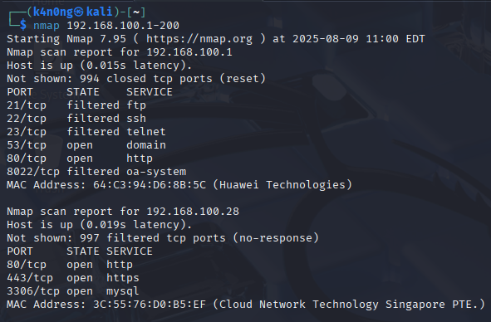
The command use to scan from IP 192.168.100.1 until 192.168.100.200

kali> nmap 192.168.100.97,102,109
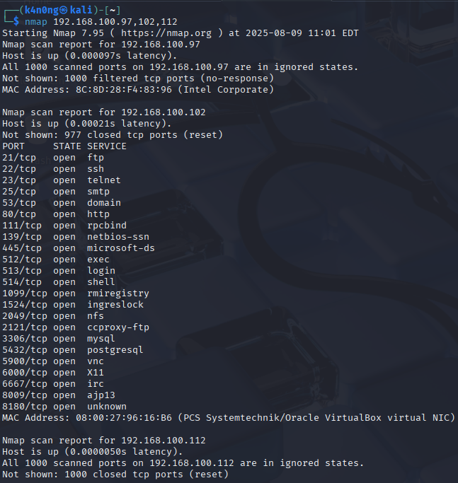

kali> vim ip.txt
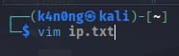

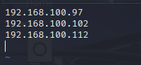

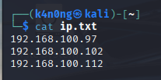

kali> nmap -iL ip.txt
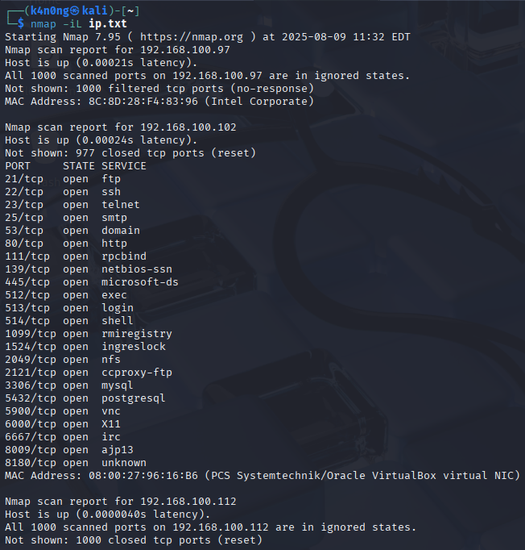
-iL ip.txt: This option tells Nmap to read input from a file. In this case:
- ip.txt should contain a list of IP addresses or hostnames (one per line).
- Nmap will scan each host listed in that file.

Kali> nmap -iR 10
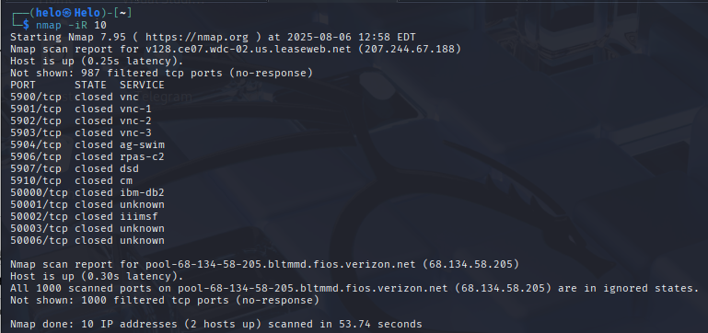
-iR 10:
- -iR stands for "input random".
- 10 tells Nmap to pick 10 random IP addresses across the Internet.
- Nmap will scan each of those 10 IPs as if they were manually entered.

Kali> nmap 192.168.100.1/24 –-exclude 192.168.100.150
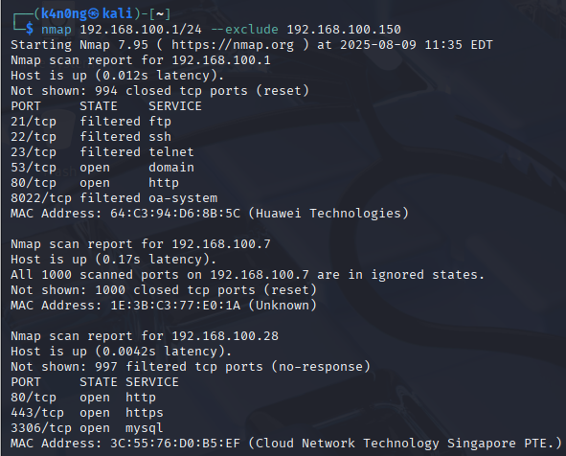
kali> nmap 192.168.1/24 –-exclude 192.168.100-200
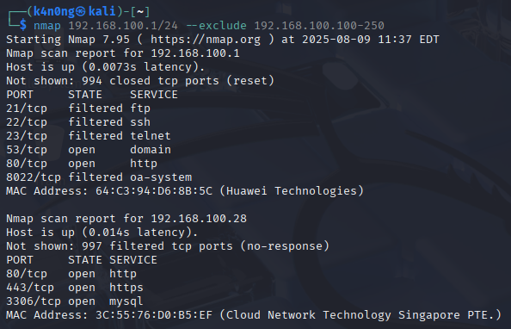
- 192.168.1.0/24: This tells Nmap to scan all 256 IPs from 192.168.1.0 to 192.168.1.255.
- --exclude: This tells Nmap to skip specific IPs.
- 192.168.1.100-192.168.1.200: Exclude all IPs in this range.
kali> nmap 192.168.1/24 –excludefile ip.txt
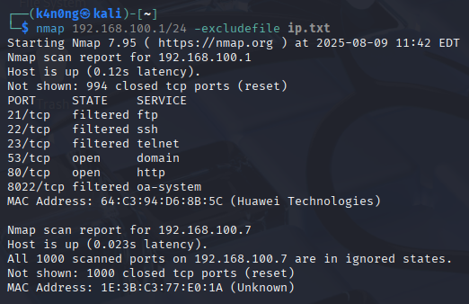

- 192.168.1.0/24: Tells Nmap to scan all 256 IPs in that subnet (from .0 to.255).
- --excludefile ip.txt: Tells Nmap to exclude all IP addresses listed in the ip.txt file from the scan.
Kali> nmap -sV 192.168.100.102
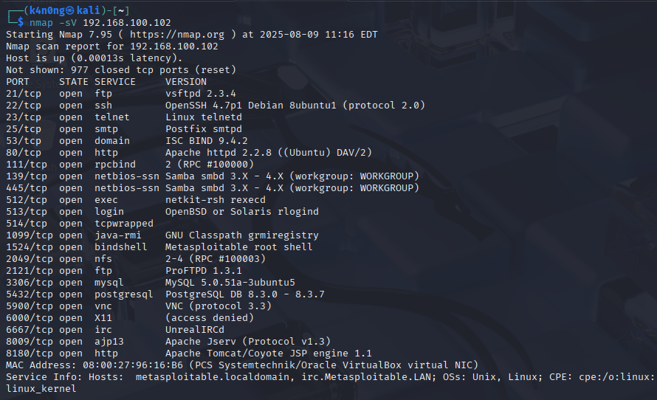

- Service Version Detection
Detects service versions running on open ports

kali> nmap -O 192.168.100.102
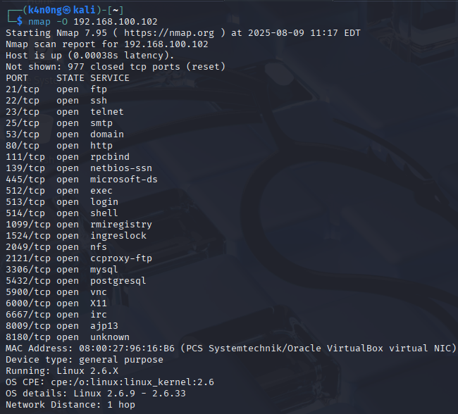

Operating Systemdetection and Attempts to detect the OS of the target machine.
kali> nmap -A 192.168.100.102
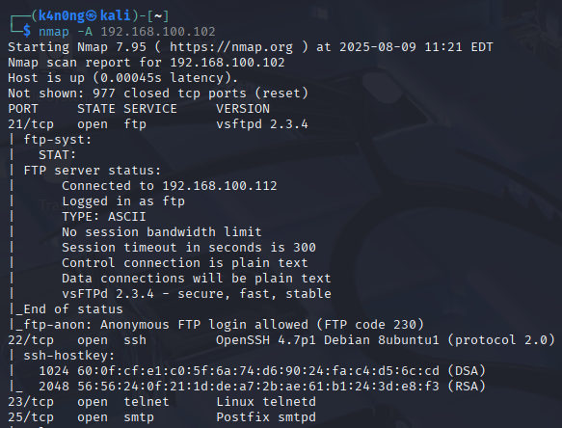
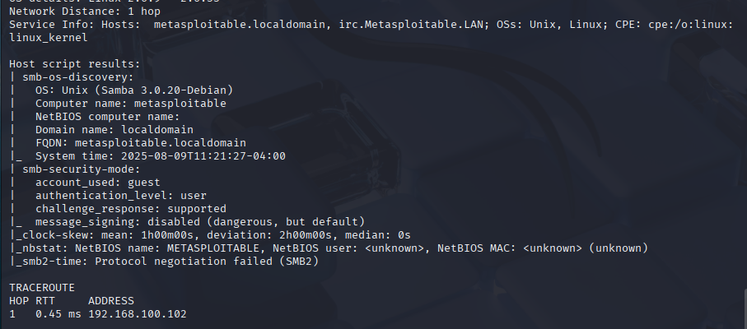

- Aggressive Scan (combines version, OS, script scanning)

- Enables OS detection, version detection, script scanning, and traceroute

Kali> nmap -v 192.168.100.102
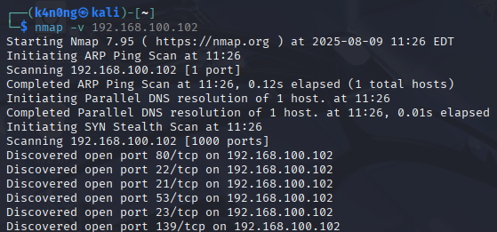
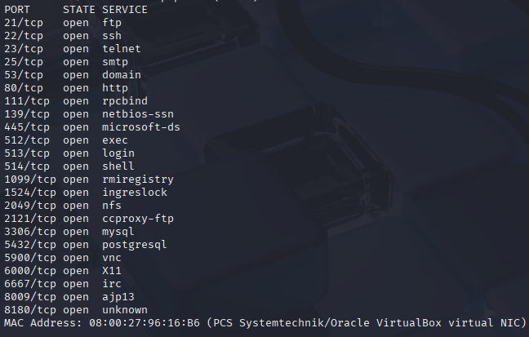
- Scan with Verbose Output
adds verbosity, shows scan progress.

KalI> nmap -vv 192.168.100.102
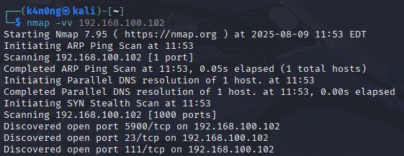

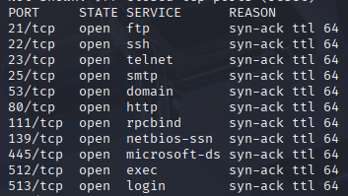

kali> nmap -T4 192.168.100.102
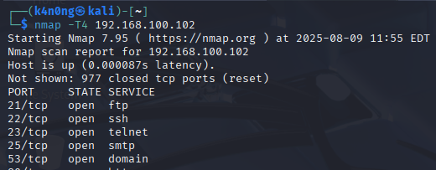

- T0 (Paranoid): Waits a long time between probes, sends packets slowly to avoid detection. Used against IDS/IPS systems to sneak in.
- T1 (Sneaky): Slower than default but less than paranoid. Still tries to avoid detection.
- T2 (Polite): Reduces bandwidth and load, nice to network admins, still reasonably fast.
- T3 (Normal):
Default timing, balanced for most situations.
- T4 (Aggressive): Speeds up scanning, assumes stable network and no IDS/IPS issues. May cause dropped packets or detection. Fast scan(recommand).
- T5 (Insane): Max speed, can flood network and cause problems or get blocked quickly.
We can combine this with all scan.
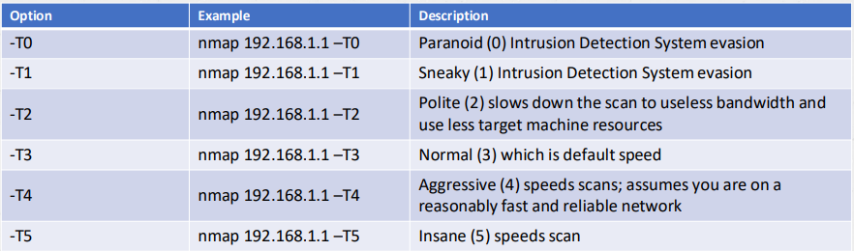
kali> nmap -v -p- 192.168.100.102
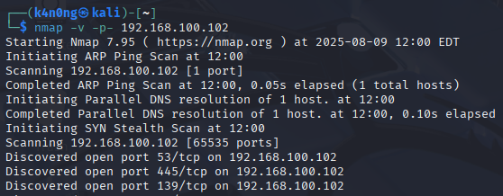

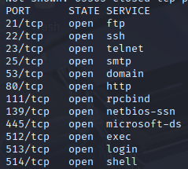

- Scan all TCP ports (1–65535) on the IP.

-p- means "scan all 65535 TCP ports".

Kali> nmap -v -p 22,80,443 192.168.100.102
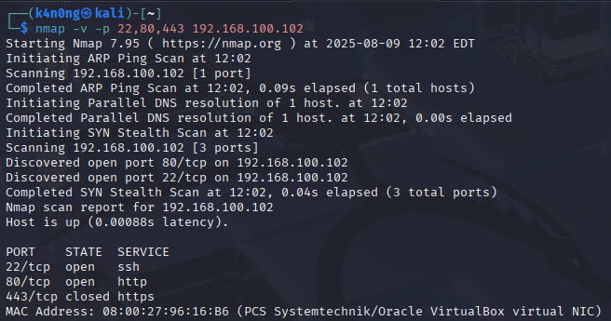
Scans only SSH (22), HTTP (80), and HTTPS (443).

kali> nmap -v -p 80,443-450 192.168.100.102
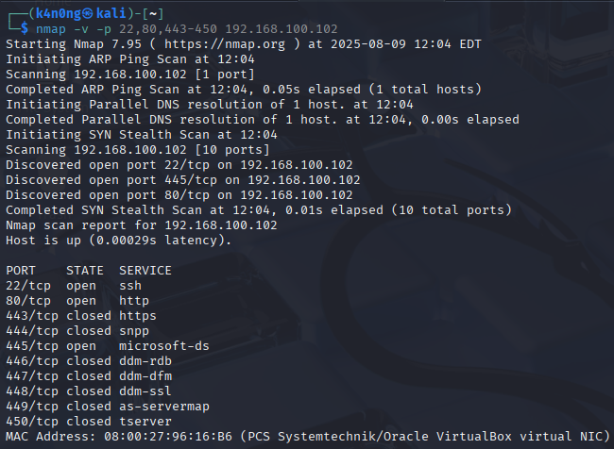

- -v: Enables verbose mode, showing more detailed progress and results.
- -p 80,443-450: Tells Nmap to scan:
+ Port 80 (HTTP),
+ Ports 443 to 450 (a small range starting with HTTPS and nearby ports).
Kali> nmap -v --top-ports 10 192.168.100.102
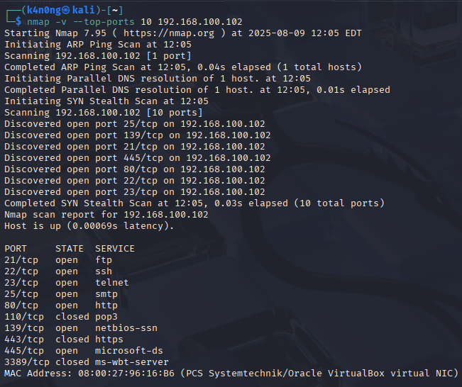

- -v: Enables verbose mode (you get more details during the scan).
- --top-ports 10: Tells Nmap to scan the 10 most commonly used TCP ports, based on statistical data.
- more command:
kali> nmap -v -sV --top-ports 10 192.168.100.102
Add service/version detection.
Kali> nmap -v -A --top-ports 10 192.168.100.102
Add OS detection and traceroute.
Kali> nmap -v --top-ports 10 192.168.100.102 -oN top10-scan.txt
Save output.

Kali> nmap -v -p 1-65535
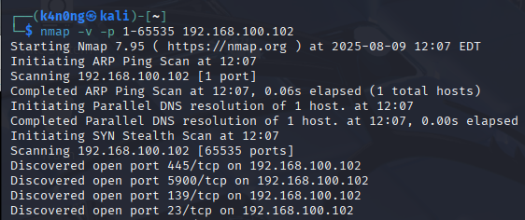

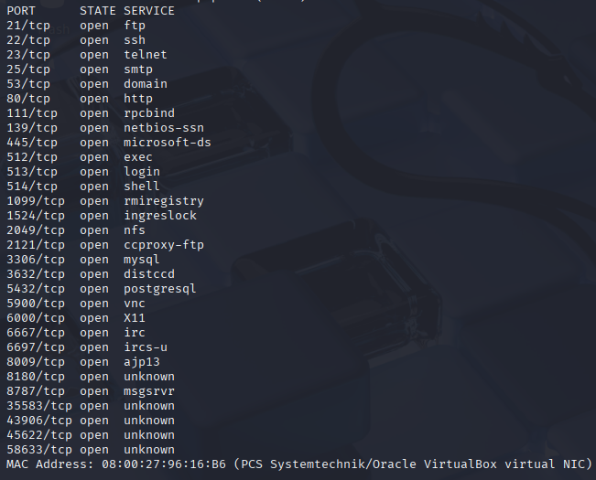

kali> nmap -v -p http 192.168.100.102
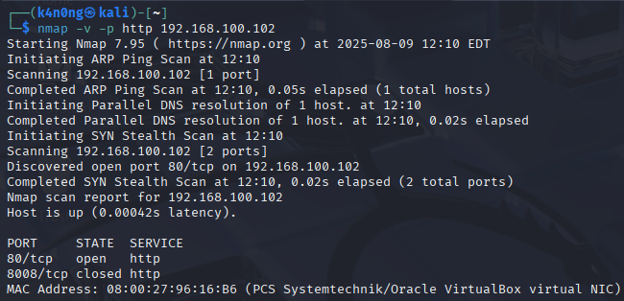

kali> nmap -v -p http* 192.168.100.102
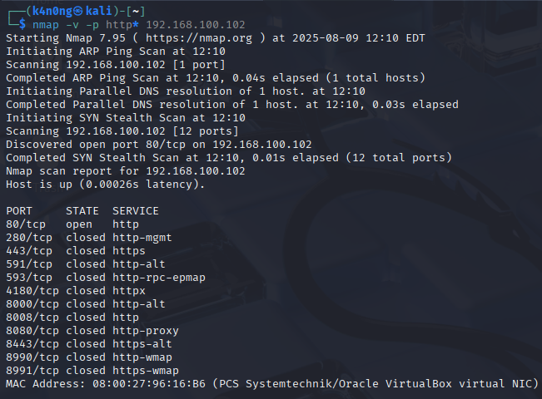
kali> nmap -v -p 80,443,8080,8000,8443 --script http-title 192.168.100.102
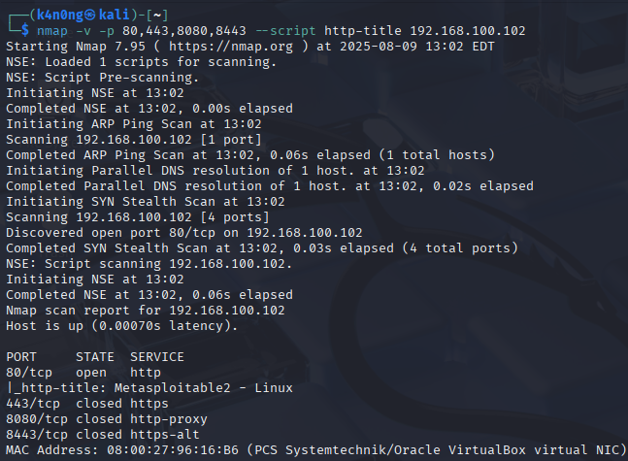
Use Nmap's --script to detect HTTP services (optional).
This will also show the title of web pages, helping identify running HTTP services.

Kali> nmap -sV -p- 192.168.100.102 | grep http
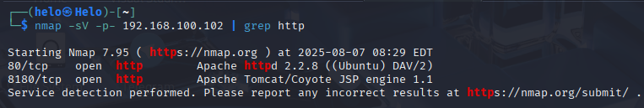
-p-: Scans all 65535 ports
-sV: Detects services
grep http: Filters results to only show HTTP-related ones.

Kali> nmap -v -p T:443,445,80,U:53 192.168.100.102
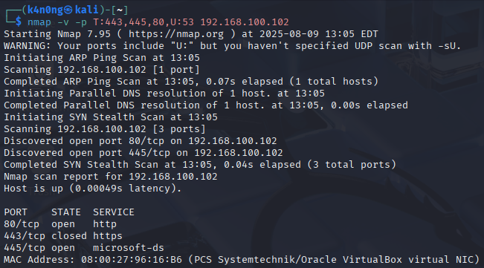
- -v: Verbose mode - shows more output during the scan.
- -p T:443,445,80,U:53:
  - T: prefix specifies TCP ports: 443 (HTTPS), 445 (SMB), 80 (HTTP)
  - U: prefix specifies UDP port: 53 (DNS)

kali> nmap -v -sS -sU -p T:443,445,80,U:53 192.168.100.102
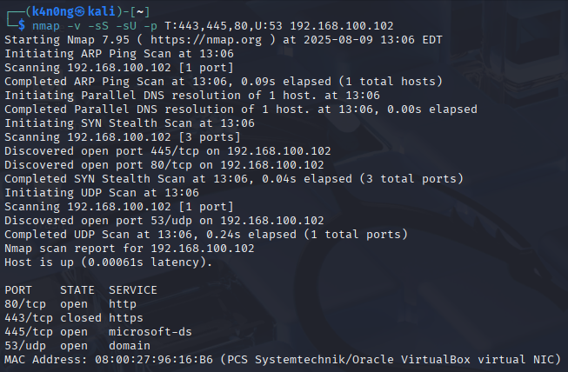
This command To properly scan both TCP and UDP ports, use.
- -sS: TCP SYN scan (stealthy and fast)
- -sU: Enables UDP scan (required for U: ports to be scanned)
- -p: Lists TCP and UDP ports explicitly
kali> nmap -v -sU -p T:443,445,80,U:53 192.168.100.102
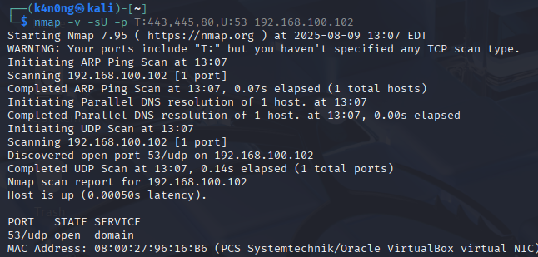

kali> nmap -v -sS 192.168.100.102
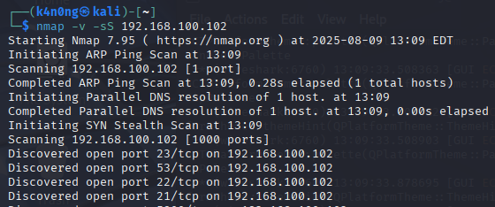

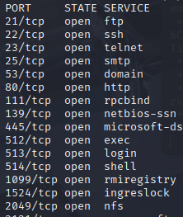

- -sS: TCP SYN scan (stealthy and fast).
- -v: Enables verbose mode, so Nmap provides more detailed output.
- after this we open wireshark
kali> wireshark
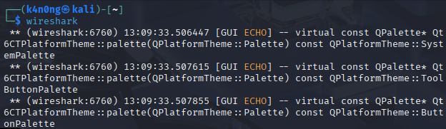

wireshark> ip.addr == 192.168.100.102 && tcp.port == 80
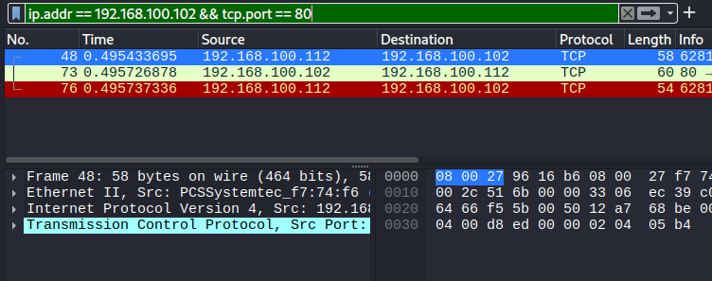
kali> nmap -v -sA 192.168.100.102
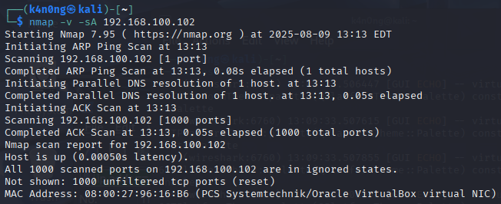
- -sA: Uses an ACK scan, which sends TCP ACK packets to determine firewall rules — not whether the port is open or closed.
Kali> nmap -v -sU 192.168.100.102
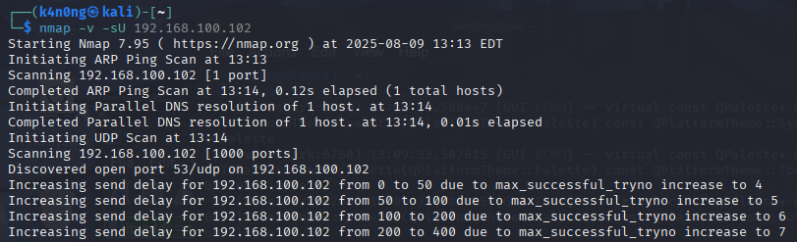
-sU: Enables UDP scan (required for U: ports to be scanned)

wireshark> ip.addr == 192.168.100.102 && udp.port
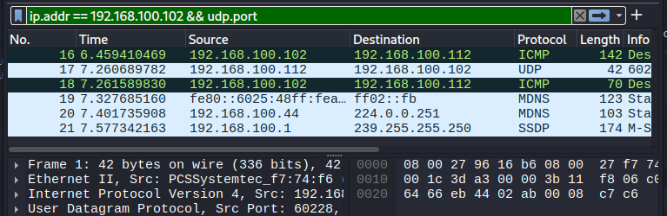
kali> nmap -v -sU -p 53,68,67,69 192.168.100.102
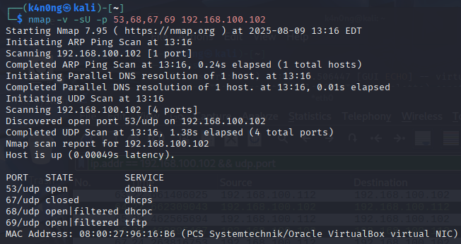
- -v: Enables verbose mode for detailed output.
- -sU: Specifies a UDP scan (instead of the default TCP).
- -p 53,68,67,69: Scans UDP ports:
  - 53 → DNS
  - 67 → DHCP server
  - 68 → DHCP client
  - 69 → TFTP (Trivial File Transfer Protocol)

kali> nmap -v -sS -sU -p T:80,443,U:53,67,68,69 192.168.100.102
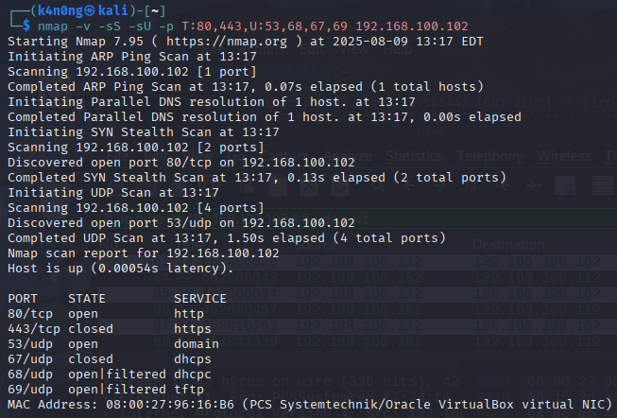
Scan Both TCP and UDP Together.

Kali> nmap -v -sT -p 80 192.168.100.102
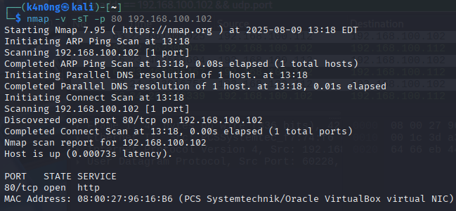

wireshark> ip.addr == 192.168.100.102 && tcp.port == 80
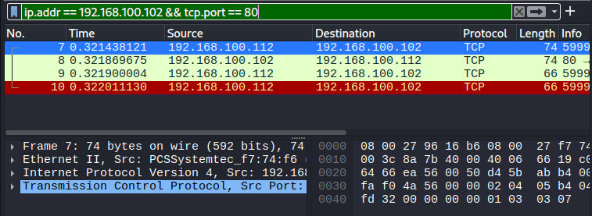
kali> nmap -v -sT 192.168.100.102
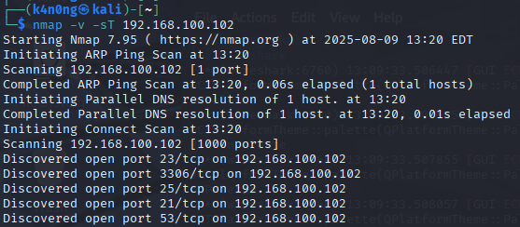

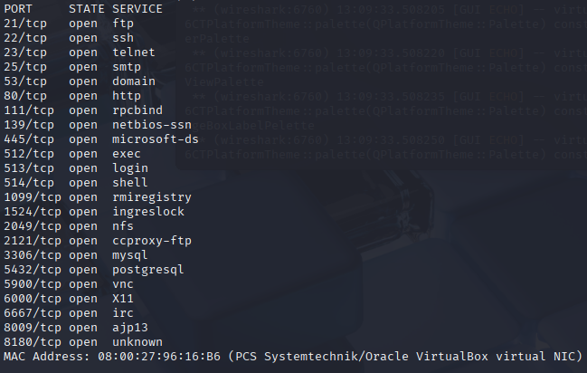
- -sT: TCP Connect Scan (also called a "full-open scan").
Kali> nmap -v -sT 192.168.100.102 -p 23
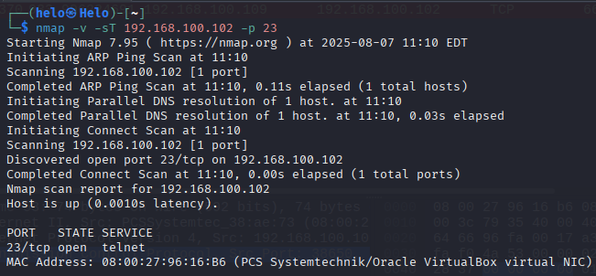
-p 23 : Scans only port 23, which is usually used by the Telnet service.
wireshark> ip.port == 192.168.100.102 && tcp.port == 23
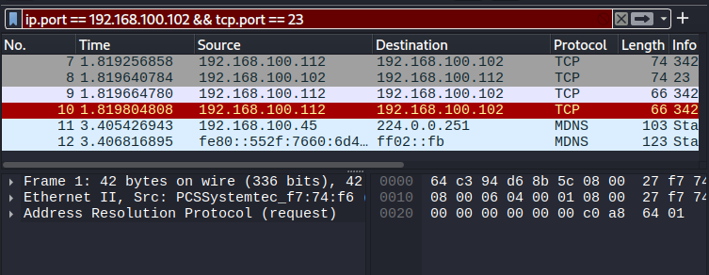
kali> nmap -v -sT -sV 192.168.100.102
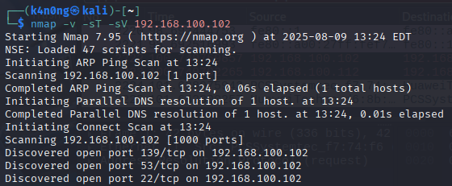

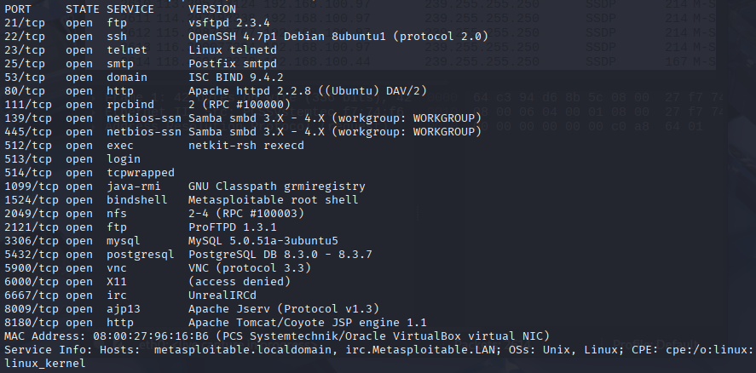
is used to perform a TCP Connect Scan with version detection on the target IP 192.168.100.102, and provides verbose output.
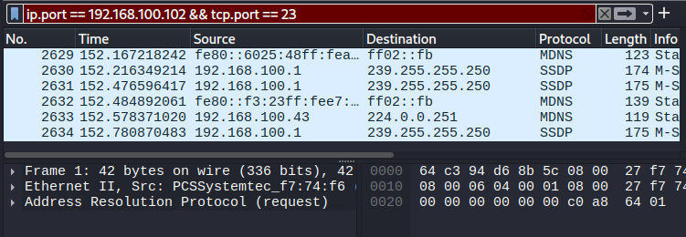
-sT: TCP Connect Scan – uses full TCP handshake to detect open ports.
-sV: Service/version detection – tries to determine software versions.

- Open the windows10:
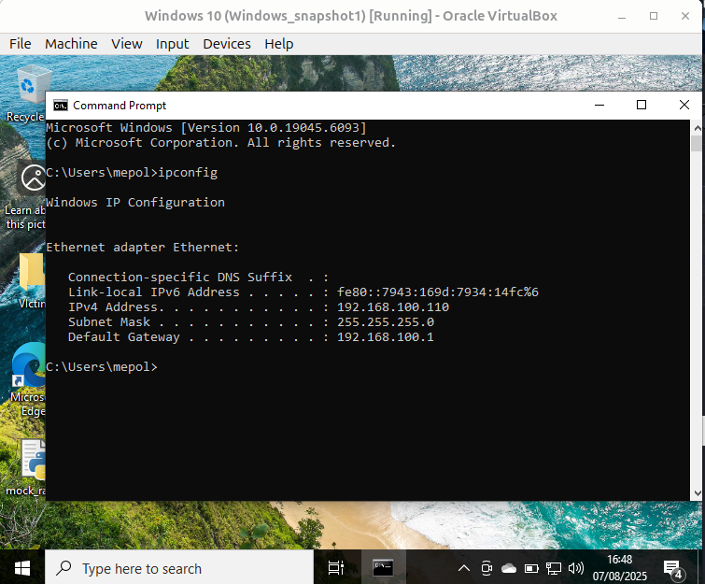

we already closed firewall.
Kali> nmap -v -sT -sV -O 192.168.100.110
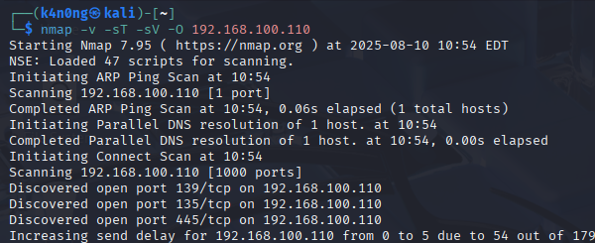
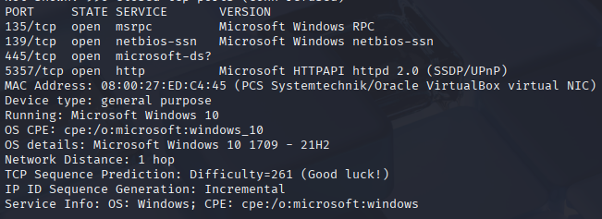
- -v: Verbose mode: Provides more detailed output. You’ll see progress and additional information during the scan.
- -sT: TCP connect scan: Nmap completes the full TCP 3-way handshake (SYN → SYN-ACK → ACK). This is less stealthy than SYN scan (-sS) but doesn’t require raw packet privileges (can be run without root).
- -sV: Service version detection: Nmap attempts to determine the version of services running on open ports (e.g., Apache 2.4.41, OpenSSH 8.2p1).
- -O: Enable OS detection: Nmap tries to guess the operating system of the target based on TCP/IP stack fingerprinting.
Kali> nmap -v -sT -sV -O -A 192.168.100.110
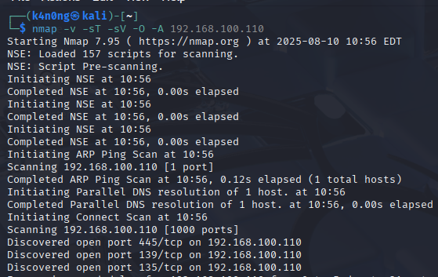

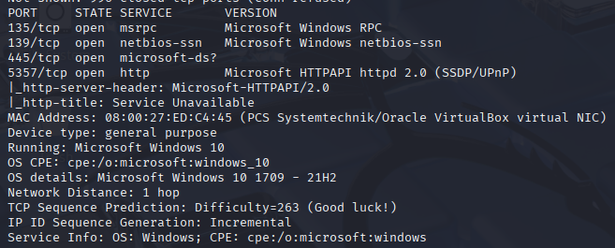
- -A : Aggressive mode: Enables a suite of advanced features:
  - OS detection (-O)
  - Version detection (-sV)
  - Script scanning (--script=default)
  - Traceroute (--traceroute)

1. Overview of Nmap
- Nmap is used to provide detailed, real-time information about networks and devices connected to them.
- It helps administrators and users understand their network infrastructure, identify vulnerabilities, and protect against potential threats.

2. Primary Uses of Nmap (Three Core Processes)

a. First Use: Detailed Information on Active IPs
- Nmap provides detailed information about every active IP address on your network.
- Process:
  - Each IP can be scanned to determine its purpose.
  - This allows administrators to check whether an IP is being used by a legitimate service or by an external attacker.
- Helps in identifying unauthorized access or malicious activity.

b. Second Use: Network-wide Information
- Nmap provides comprehensive information about the entire network.
  - It generates a list of live hosts (active devices) and open ports.
  - It identifies the operating system (OS) of each connected device.
- Applications:
  - Ongoing System Monitoring: Tracks network activity and ensures everything is functioning as expected.
  - Penetration Testing: Used alongside tools like the Metasploit Framework to probe network vulnerabilities and repair them.
  - Example: Nmap can help identify open ports that could be exploited by attackers.

c. Third Use: Website Security
- Nmap is valuable for users looking to protect personal and business websites.
- Process:
  - Scanning your own web server (especially if hosted from home) simulates how a hacker might attack your site.
  - By "attacking" your own site in this way, you can identify security vulnerabilities before they are exploited by actual attackers.
- Proactive security testing to strengthen defenses.

3. Key Takeaways
- Network Inventory and Security: Nmap helps administrators manage and secure their networks by providing detailed information about active IPs, live hosts, open ports, and connected devices.
- Integration with Other Tools: Nmap can work alongside frameworks like Metasploit to perform advanced penetration testing and vulnerability assessment.
- Website Protection: Nmap enables users to simulate attacks on their own websites, helping them identify and fix security weaknesses proactively.

Run a ping Scan

1. Overview of Ping Scan
- One of the basic functions of Nmap is to identify active hosts (devices) on your network.
- Nmap performs this by conducting a ping scan, which detects all IP addresses currently online without sending any packets directly to those hosts.
  - A ping scan is a non-intrusive way to discover active devices on a network.
Kali> nmap -sP 192.168.100.1/24 (old syntax)
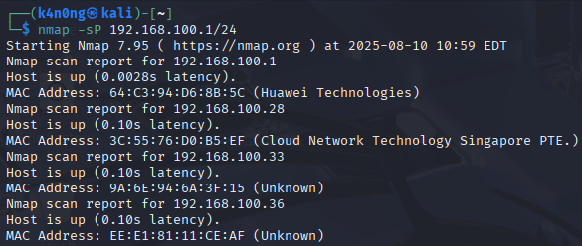
kali> nmap -sn 192.168.100.1/24 (New syntax)
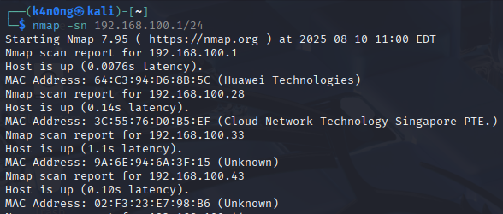
- -sn (Ping Scan): Skips port scanning and only checks which hosts are up.
- 192.168.100.1/24: Scans the IP range 192.168.100.0 to 192.168.100.255.
- Nmap will send ICMP Echo Request and sometimes ARP requests (on local LAN) to identify live devices.
- Output will list each detected host and its IP (and sometimes hostname + MAC address).

Scan an IPV6 Target
The -6 parameter is used to perform a scan of IP version 6 target.
Kali> nmap -6 fe80::a00:27ff:fe96:16b6
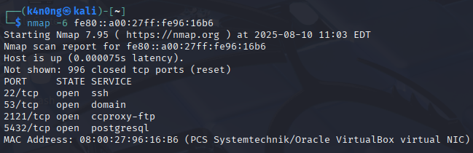

End Part 1
contact:
Gmail: ninkanong200620@gmail.com

